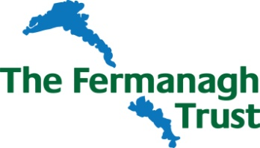

Homeless Support Fund
Application Form

Applicant Details
Name of
Organisation/
Group
Brief Description of Organisation
Charity Registration No (If applicable)
 | Name |  |  | Address | Telephone & Email

Chairperson

Secretary

Contact Person for this Application

Project/Activity Details

Title

Location
(attach map if appropriate)

Summary
(please provide further details including relevant experience of your organisation’s work in supporting those facing homelessness)

How will this project specifically target people experiencing homelessness?

Outline the project outcomes and how they will benefit individuals.

Overall Cost of Project/Activity

Amount of Funding sought from the
Encirc Homeless Support Fund

Estimated Start Date (no retrospective applications can be accepted) |  |  |  | Estimated Completion Date
Amount of funding from other sources (please detail sources)

Breakdown of main costs of project/activity

Will the project / activity require ongoing funding afterwards? |  | YES / NO | If yes, what are the sources of this funding?
Further/Supporting Information (ie, how will the project benefit the local community, how many people will directly/indirectly benefit from this funding, undertaking that the funding will be spent by 31st March 2027).

Details of any attachments to this application

Supporting documents required:
A copy of your organisation’s constitution
Written confirmation of charitable status if you are a registered charity
A copy of your organisation’s latest accounts
Most recent bank statement from all accounts

I/we the undersigned have read and agree to be bound by the enclosed Terms and Conditions of the Awards.

Signature………………………………………
Date……………………………….…………….

Title………………………………………………

Return completed form by 12 noon on Friday 11th September 2026 together with supporting documents to –

The Secretary, The Fermanagh Trust, Fermanagh House, Broadmeadow Place, Enniskillen, Co Fermanagh, BT74 7HR Tel: 02866320210 Email: secretary@fermanaghtrust.org

To sign up the Fermanagh Trust email newsletter tick here

