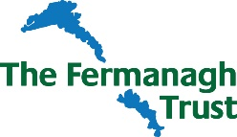

Fermanagh Trust
Trainee Centre Manager

Guidance notes for Applicants

Application Forms to be returned by email to: gemma@fermanaghtrust.org
Or direct completed form to:
Gemma Johnston
The Fermanagh Trust,
Fermanagh House,
Broadmeadow Place,
Enniskillen,
Co Fermanagh
BT74 7HR.

Applicants, please note the following key dates:
Application Deadline: Monday 20th June 10.00am
Interviews will be held in Fermanagh House, Enniskillen on: Thursday 23rd June

Invitation to Interview will be emailed to successful candidates no later than 12 noon 21st June 2022.

Should you have any specific enquiries related to this position or have any access requirements we need to be aware of should you be offered an interview, please contact:
Gemma Johnston
E: gemma@fermanaghtrust.org
or
T: 02866320210

