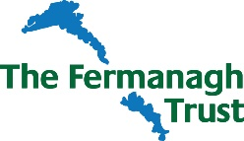

**Fermanagh Trust**

**Part time Receptionist**

**Guidance notes for Applicants**

Application Forms to be returned by email to: marilyn@fermanaghtrust.org

Or direct completed form to:

Marilyn Quinn

The Fermanagh Trust,

Fermanagh House,

Broadmeadow Place,

Enniskillen,

Co Fermanagh   
BT74 7HR.

Applicants, please note the following key dates:

Application Deadline: Monday 20th June, 10.00am

Interviews will be held in Fermanagh House, Enniskillen on: Friday 1st July 2022

Start Date: This post will commence: September 2022

Should you have any specific enquiries related to this position or have any access requirements we need to be aware of should you be offered an interview, please contact:

Marilyn Quinn

E: marilyn@fermanaghtrust.org

or

T: 02866320210