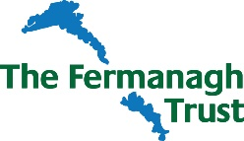

Fermanagh Trust
Part time Finance Officer

Guidance notes for Applicants

Application Forms to be returned by email to: gemma@fermanaghtrust.org
Or Applications can be directed to: Gemma Johnston, Fermanagh Trust, Fermanagh House, Broadmeadow Place, Enniskillen, BT74 7HR

Applicants, please note the following key dates:

Application Deadline: Monday 20th June, 10.00am
Shortlisting: Monday 20th June
Interviews will be held in Fermanagh House, Enniskillen on: Friday 24th June

Invitation to Interview will be emailed to successful candidates no later than 12 noon
21st June 2022.

Should you have any specific enquiries related to this position or have any access requirements we need to be aware of should you be offered an interview, please contact:
Gemma Johnston
E: gemma@fermanaghtrust.org
or
T: 02866320210

