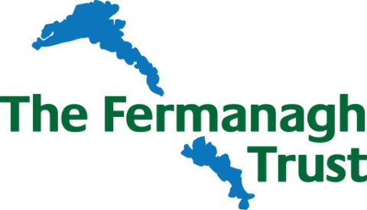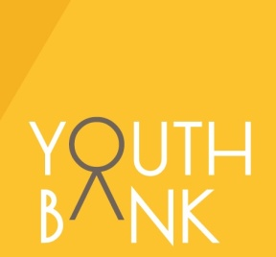
Fermanagh YOUTHBANK 2017
APPLICATION FORM

Your lives and your community
What’s going on? What matters?
What could make a difference?

Ever wanted to do something about an issue that affects young people or your local community between ages of 11 and 25? Got a good idea for an activity or project that
would make a difference for others? If the answer is yes, then you can apply to
Fermanagh YouthBank for a grant of up to £1,000 to help make it happen!

When we are trying to work out who will get a grant, our YouthBank will look to see if your idea is:
- Youth-led – This means it should be your idea and you are the ones that will make it happen. You can ask an adult to support you in what you want to do.

Clear and realistic
- Good value for money
- Going to do something positive about an issue that affects young people or your local community AND meets one of the following;

Key priorities for Youth Bank Applications 2017 which support initiatives involving young people between 11 and 25 years of age;
  - Open and inclusive safe space and events to ease youth pressure / stress and encourage interaction
  - Suicide Awareness – development of training, engagement and services
  - Mental Health – improvement in training and services

- Group Name (if you have one):

- Supporting Organisation (if you have one):

- Contact Address:

- Postcode:

- Tel: Mobile:

Email:

6 Name of person completing this form: Age: Sex:
7 Using the grid below include information about the other members of your group (minimum of 1 or 2 other people)

Name | Age | Gender: male or female

- Title of project idea (if you have one):

- Tell us about your idea?

- To get a grant your idea must do something positive about an issue that affects young people or your local community. What issue will your activity do something about and how will it specifically make a difference?

- Where will your project take place and how often will it take place?

- Apart from your own group, how many people, and in what age-range, will benefit from your project? (Please put figures in any of the boxes below that are relevant to you. We understand that there may be nobody else other than your group who benefits from this funding).
0-11 years of age 11-16 17-18

  - ears of age 25 + 60 +

- How long will this project last and when will it begin? _________________________________

- Is anyone else helping you with your project or will they be involved in delivering it? Please tell us who they are, what their role is and how they will help?

- Please tell us what you need funding for.

Things you’ll need | Cost each | Number needed | Total
 |  | Total Cost of Project:

- What is the total funding you would like from Fermanagh YouthBank?

- If your activity is going to cost more than you are applying to Fermanagh YouthBank for, please tell us where the rest of the money you need will come from.

________________________________________________________________________________________
Signature (of person completing this form): Date:

Please return completed form to:
Fermanagh YouthBank C/O Hazel McFarland
Fermanagh House Broadmeadow Place Enniskillen
BT74 7HR 02866320210
hazel@fermanaghtrust.org
Closing Date: 5pm 7th April 2017

If you require any more information regarding this form or need assistance with completing it then please contact the address above.

OFFICIAL USE ONLY:
Eligible idea (Y/N) | Interview (date and time) | YB  Interviewers (2 names) | Score (number) | Grant (amount in  £s) | YB support workers (2 names) | Contract signed (date) | Feedback/finance form received (date) | Receipts attached and checked (date)

