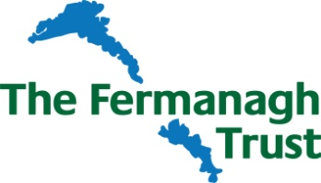

Teiges Mountain Wind Farm Fund Awards 2020/2021

Strategic Projects Revenue Grants - Application Form

Applicant Details
Name of organisations involved in project
Brief Description of each organisation
Charity Registration No.s (If applicable)
 | Name / Org | Address | Telephone & Email

Key contact person for this project

Project/Activity Details

Title

Location
(attach map if appropriate)

Summary
(please attach further details if necessary)

Who will benefit from the results of this project/activity?

Overall Cost of Project/Activity

Amount of Funding sought from
Teiges Mountain Wind Farm Fund

Estimated Start Date (no retrospective applications can be accepted) |  | Estimated Completion Date
Amount of funding from other sources (please detail sources)

Breakdown of main costs of project/activity

Will the project/activity require ongoing funding aferwards? | Yes / No | If Yes, what are the sources of this funding?
Further/Supporting Information (ie, how will the project benefit the local community, how many people will directly/indirectly benefit from this funding, project is located within 5km of the Windfarm).

Details of any attachments to this application

All partners in project must sign application form

We the undersigned have read and agree to be bound by the enclosed Terms and Conditions of the Awards.

Name | Organisation | Position | Date | Signature

Return completed form by 12noon Friday 13th November 2020, together with any supporting documents to –

The Director, The Fermanagh Trust, Fermanagh House, Enniskillen, BT74 7HR.
Tel: 028 66320210 or email: hazel@fermanaghtrust.org

To sign up the Fermanagh Trust email newsletter tick here

