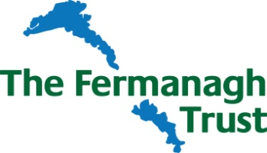

Slieve Rushen Wind Farm Fund Awards 2020 / 2021

Application Form

Applicant Details
Name of
Organisation/Group
Brief Description of Organisation
Charity Registration No (If applicable)
 | Name | Address | Telephone & Email

Chairperson

Secretary

Contact Person for this Application

Project/Activity Details

Title

Location
(attach map if appropriate)

Summary
(please attach further details if necessary)

Who will benefit from the results of this project/activity?

Overall Cost of Project/Activity

Amount of Funding sought from
Slieve Rushen Wind Farm Fund

Estimated Start Date (no retrospective applications can be accepted) |  | Estimated Completion Date
Amount of funding from other sources (please detail sources)

Breakdown of main costs of project/activity

Will the project/activity require ongoing funding afterwards? | Yes / No | If Yes, what are the sources of this funding?
Further/Supporting Information (ie, how will the project benefit the local community, how many people will directly/indirectly benefit from this funding, undertaking that the funding will be spent by 31st March 2021, project is located within 12km of the Windfarm).

Details of any attachments to this application

I/we the undersigned have read and agree to be bound by the enclosed Terms and Conditions of the Awards.

Signature…………………………………………………………….……………………………………….Date……………………………….…………….

Title………………………………………………………………………………………………………………………………………………………………...

Return completed form by 12noon Friday 29th May 2020, together with any supporting documents to –

The Director, The Fermanagh Trust, Fermanagh House, Enniskillen, BT74 7HR.
Tel: 028 66320210 or email: hazel@fermanaghtrust.org

To sign up the Fermanagh Trust email newsletter tick here

