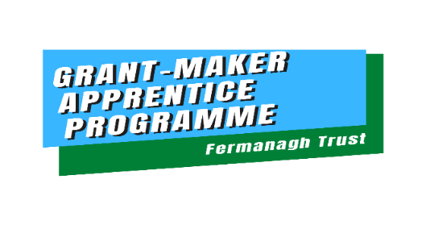
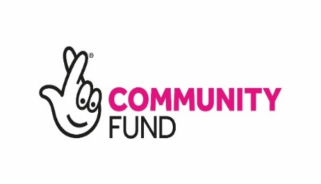

Grant-Maker Apprentice Programme (G-MAP)
Application Guidance 2020-21

Purpose:
To enable young people aged 16-25 to make a positive impact in their community, develop skills and knowledge to become active and empowered future leaders and influencers.

Participants will:
- Participate in a varied programme of Team-building, Individual & Group work Activities
- Champion, promote and allocate funding to an area of particular personal interest to make a positive contribution to local or wider community and or society
- Work with others to develop an application process to assess, select and award Grants to individuals or groups
- Have the opportunity to become a participating member of an existing Community Board
- Improve knowledge & skills in a number of key areas improving confidence, self-esteem and future employability

Application process: ORGANISATION Nomination

2-Step Process

Step 1:

Complete Application Form

Part A:

Nomination from Organisation or group stating in no more than 500 words why they are putting this young person forward for this opportunity.

Essential Criteria:
- Age 16-25
- Shows natural leadership skills and qualities
- Passionate about their community and making a difference
- Have shown an active interest in making a difference
- Can commit to a 12 week programme including afterschool and weekend meetings

Part B:
Young person’s personal Statement
- Explain in no more than 200 words why you believe you should be selected for this course.

Successful Applications will be invited to Step 2:

Step 2
1:1 Meeting with Programme Coordinator
- Informal Meeting to discuss application, to discuss areas of interest for the young person.
- Ensure times, venue, transport issues can be resolved
Application process: SELF – Nomination

2-Step Process

Step 1:
Complete Application Form:

Young person’s personal statement in no more than 400 words why they believe they should be allocated a place on this programme.

Criteria:

- Age 16-25
- Shows natural leadership skills and qualities
- Passionate about their community and making a difference
- Have shown an active interest in making a difference
- Can commit to a 12 week programme

Step 2:
1:1 Meeting with Programme Coordinator

Deadline for return of Applications: Friday 23rd October 12pm

Selection:
Successful and unsuccessful candidates will be notified of their successful application within 2 days of 1:1 Meeting.

Successful Applicants 1st Meeting date: 10/11/2020 – Virtual Meeting for Q&A

For further information please visit: www.fermanaghtrust.org/grantmakerapprenticipprogramme/

Contact:

Sonya Johnston
Programme Manager

Fermanagh Trust
Fermanagh House
Broadmeadow Place
Enniskillen
Co. Fermanagh
BT74 7HR

Tel: (028) 66 320 210
Fax: (028) 66 320 230

Email: sonya@fermanaghtrust.org Web: www.fermanaghtrust.org

